1 and 2.
SELECT ST_POINT(-93.610065, 41.948637) AS point1;
SELECT ST_DISTANCE(
ST_POINT(-93.610065, 41.948637),
ST_POINT(-93.610229, 41.997339)
) AS distance_in_degrees;
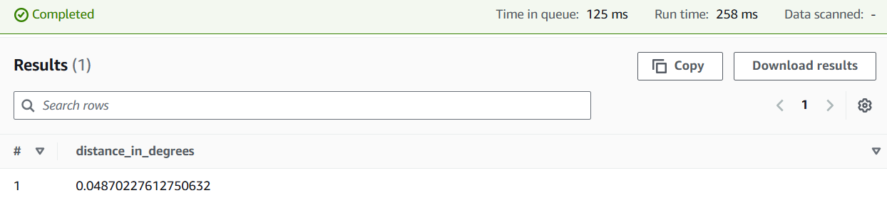
3.
WITH line AS (
SELECT ST_LINESTRING(
ARRAY[
ST_POINT(-93.610065, 41.948637),
ST_POINT(-93.610229, 41.997339)
]
) AS line_string
),

point AS (
SELECT ST_POINT(-93.619738, 41.972017) AS point3
)

SELECT
ST_DISTANCE(line_string, point3) AS distance_in_degrees
FROM
line, point;
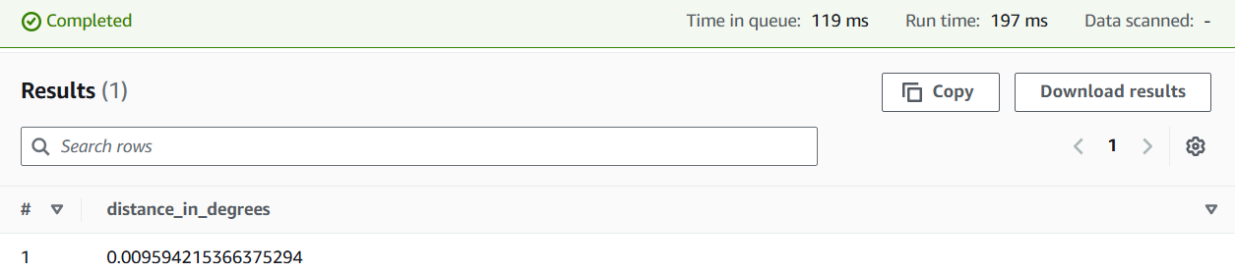
4.
WITH line AS (
SELECT ST_LINESTRING(
ARRAY[
ST_POINT(-93.610065, 41.948637),
ST_POINT(-93.610229, 41.997339)
]
) AS line_string
),

point AS (
SELECT ST_POINT(-93.619738, 41.972017) AS point3
)

SELECT
ST_DISTANCE(line_string, point3) * 364567 AS distance_feet
FROM
line, point;
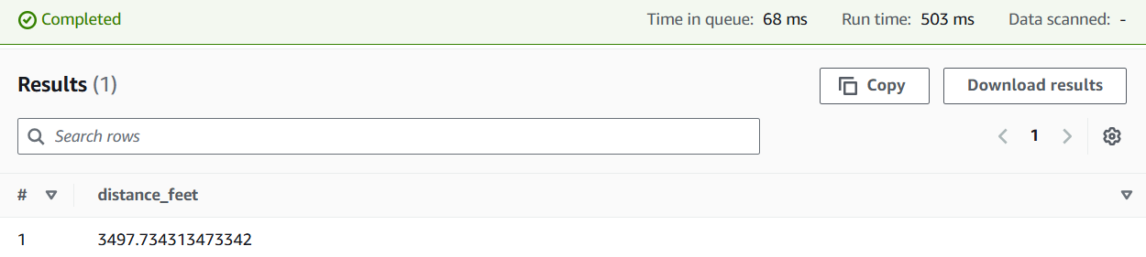
5.
WITH line AS (
SELECT ST_LINESTRING(
ARRAY[
ST_POINT(-93.610065, 41.948637),
ST_POINT(-93.610229, 41.997339)
]
) AS line_string
),

point AS (
SELECT ST_POINT(-93.619738, 41.972017) AS point3
)

SELECT
ST_DISTANCE(line_string, point3) * 364567 AS distance_feet
FROM
line, point;
